AUSTRALIAN COUNCIL FOR THE DEFENCE OF GOVERNMENT SCHOOLS

PRESS RELEASE 554#

COALITION EDUCATION AGENDA

PERFECTLY PREDICTABLE.

Voters are astounded at the Coalition’s revolutionary education agenda.

Yet this agenda was predictable for anyone who could see the signs before the election.

There is a direct relationship between

the IPA,

the Audit and

the Budget:
Before the election the Institute of Public Affairs claimed that
The Institute of Public Affairs examines education policy from the principle that competition and choice is as effective at ensuring quality as it is in other Australian sectors. In primary, secondary and tertiary education, the need for the application of these principles is clear. See https://www.ipa.org.au/sectors/education
Crikey.com at http://www.crikey.com.au/2013/09/18/ipa-adds-to-its-wishlist-and-almost-half-are-on-abbotts-cards/ analysed the influence of the IPA on Abbott’s government
Abbott and Pyne agreed to a so-called ‘unity ticket’ with Gillard on Gonski funding but it was obvious that the ticket was frayed, if not trashed from the very beginning. A budget ‘crisis’was systematically manufactured and legitimated by the Australian Commission of Audit which recommended that

It is not clear to the Commission that the projected step-up of growth in Commonwealth schools funding over the next decade has been sufficiently justified. While the Government has locked in funding agreements for the next four years, new arrangements should apply from 2018 onwards….A simpler arrangement is proposed, whereby the States fund all schools, including the non-government sector.

Hey Presto: the Hocky-Abbott-Pyne triumvirate de-regulate public education, cut education funding, especially after 2018, and push responsibility for education back to the States.

The full text of the Australian Commission of Audit recommendations on educationis at :

http://www.ncoa.gov.au/report/phase-one/part-b/7-7-schools-funding.html

Here is the text:

NATIONAL COMMISSION OF AUDIT

7.7 Schools funding
School education is a significant area of Commonwealth spending, with forecast expenditure of $12.9 billion in 2013-14.
While the Commonwealth does not have specific constitutional responsibility for the provision of school education, it provides significant funds to the States for schools.
Currently, spending on government schools is dominated by the States, which provide over 80 per cent of public funding. Commonwealth spending is primarily directed to non-government schools.
The implementation of the previous Government’s Better Schools Plan (otherwise known as the Gonski reforms) would see significant growth in Commonwealth spending on schools over the next decade, at an average rate of over 9.2 per cent per year in nominal terms (see Chart 7.11). Key drivers of spending growth include funding indexation arrangements, the transition to a higher ‘per-student’ rate of funding and growth in student enrolments.
As a consequence of the funding reforms, the relative funding contributions between the Commonwealth and States would change materially. The Commonwealth would no longer be just the primary public funder of non-government schools: it would be a significant funder of government schools’ recurrent costs, with the Commonwealth’s proportion of contributions projected to increase to around 25 per cent by 2023-24.
Chart 7.11: Projected Commonwealth funding for schools
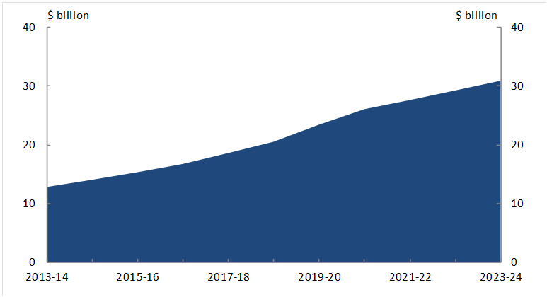
Source: National Commission of Audit.
The Commission supports government investment in schooling. Strong education contributes to strong employment, as well as broader productivity, health and social outcomes.
However, increasing funding does not necessarily equate to better student outcomes. Between 2000 and 2012, despite real growth in government funding of over 3.8 per cent per year, Australian student results in international tests declined.
The Commission considers that in terms of the efficiency and effectiveness of school funding, what matters most is how schools and classrooms are run. These factors are likely to have a greater impact on student outcomes than spending alone.
The new school funding arrangements are complex, based on a per-student resourcing standard with loadings to take account of student disadvantage.
In theory, the approach is needs-based – it calculates funding according to student characteristics, such as whether they have low socio-economic status, are Indigenous or live in a remote location.
However, the per-student rate of funding that drives the model is not based on a detailed analysis of the cost of delivering education and may not represent its efficient price. Further details on school funding arrangements are outlined in Section 9.7 of the Appendix to this report.
It is not clear to the Commission that the projected step-up of growth in Commonwealth schools funding over the next decade has been sufficiently justified. While the Government has locked in funding agreements for the next four years, new arrangements should apply from 2018 onwards. The amount of ‘per-student’ funding in 2017 should be maintained and then indexed by an appropriate measure to reflect reasonable inflation in school costs.
The Commission also considers roles and responsibilities for school education should be streamlined. As the operators of schools and school systems, the States have much greater day-to-day influence over schooling policy, particularly given they control teacher wages and conditions, hiring and firing decisions and principal autonomy.
Overlapping and duplicative responsibilities and arrangements between the Commonwealth and the States result in significant reporting and compliance burdens for them in what is essentially their area of constitutional responsibility. The Commonwealth’s responsibility for non-government schools adds to this administrative cost.
A simpler arrangement is proposed, whereby the States fund all schools, including the non-government sector.
This should form part of considerations of the broader reforms to federal financial relations outlined in Chapter Six, however the Commission considers progress on schools should be made independent of progress on Commonwealth-State funding reform.
The Commission proposes Commonwealth funding for school education be provided to each State in three pools – one for government schools, one for Catholic systemic schools and one for independent schools.
As occurs now, the Catholic Education Commission in each State would be given responsibility for allocating funding between Catholic systemic schools. Given the mix of small systems (such as the Lutheran system) and completely independent schools in the independent sector, the States would have responsibility for allocating funding within this sector, as well as government schools.
To ensure there would be adequate and ongoing funding in the non-government sector, there would be no capacity to reallocate funding between the pools.
Each State should identify and publish its own needs-based formula for allocating school funding. They should also publish data on school outcomes on a consistent basis and continue to participate in national and international testing and the national curriculum. Other than that, there would be minimal reporting to the Commonwealth.
Under this approach a significant reduction in the size of the Commonwealth Department of Education could be achieved.

Recommendation 23: Schools funding
While the Commonwealth does not have specific constitutional responsibility for school education, it provides significant funding to the States. The Commission recommends changing funding arrangements to simplify Commonwealth-State responsibilities and make school funding more affordable by:
- transferring all policy and funding responsibility for government and non government schools to the States, with annual funding provided in three separate, non-transferrable pools - one each for government schools; Catholic systemic schools and independent schools;
- applying requirements on the States to:
  - publish how they allocate funds to schools;
  - participate in national and international testing; and
  - publish student outcomes on a consistent basis;
- basing Commonwealth funding from 2018 onwards on 2017 levels, with:
  - a 2017 per student funding amount calculated for the government and non government school sectors in each State and Territory;
  - annual funding for each sector in each jurisdiction calculated as the per student amount, adjusted for the number of students enrolled in that year and indexed by a weighted average of the CPI and the relevant Wage Price Index; and
- significantly reducing the size of the Commonwealth Department of Education.

LISTEN TO DOGS PROGRAM
ON 3CR
855 ON THE AM DIAL
12.00 NOON SATURDAYS

